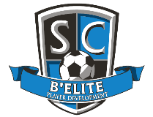

B’ Elite Soccer Club Sponsorship Options

Sponsorship Options Bronze Silver Gold Platinum

X

X

X

**$1,999**

X

X

X

X

**$1,499**

X

X

**$599**

X

X

X

X

***Social Media / Banner***

Advertisement on our Social Media platforms

Your logo on dedicated monthly club newsletter

Dedicated ad popup

**$299**

X

***Banners @ B’ Elite PD SC per year***

Your Logo banner on website

Your logo on dedicated banner – 3x5

***Uniform Logo per year***

Your logo on Keeper jerseys

Your logo on team uniform (1 team)

Your logo on team uniform (all teams)